CC Assignment 2

Installation and Configuration of virtualization using KVM

- Install virtualisation tool
sudo apt update
sudo apt install qemu-system-x86 libvirt-daemon-system libvirt-clients virt-manager
- Verify Installation by: virt-host-validate

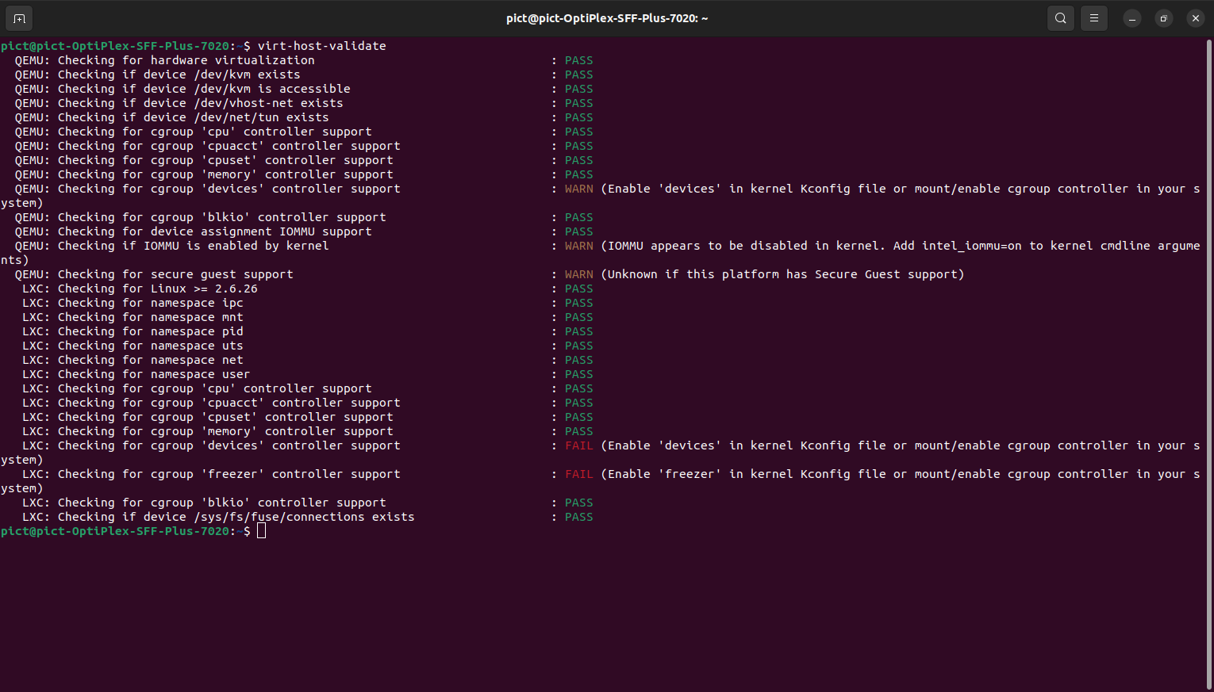

- Enable Packet Forwarding
This is essential if you want your VMs to communicate with the outside world through your host's network.
  - Open the file: sudo nano /etc/sysctl.conf
  - Uncomment or add this line: net.ipv4.ip_forward = 1
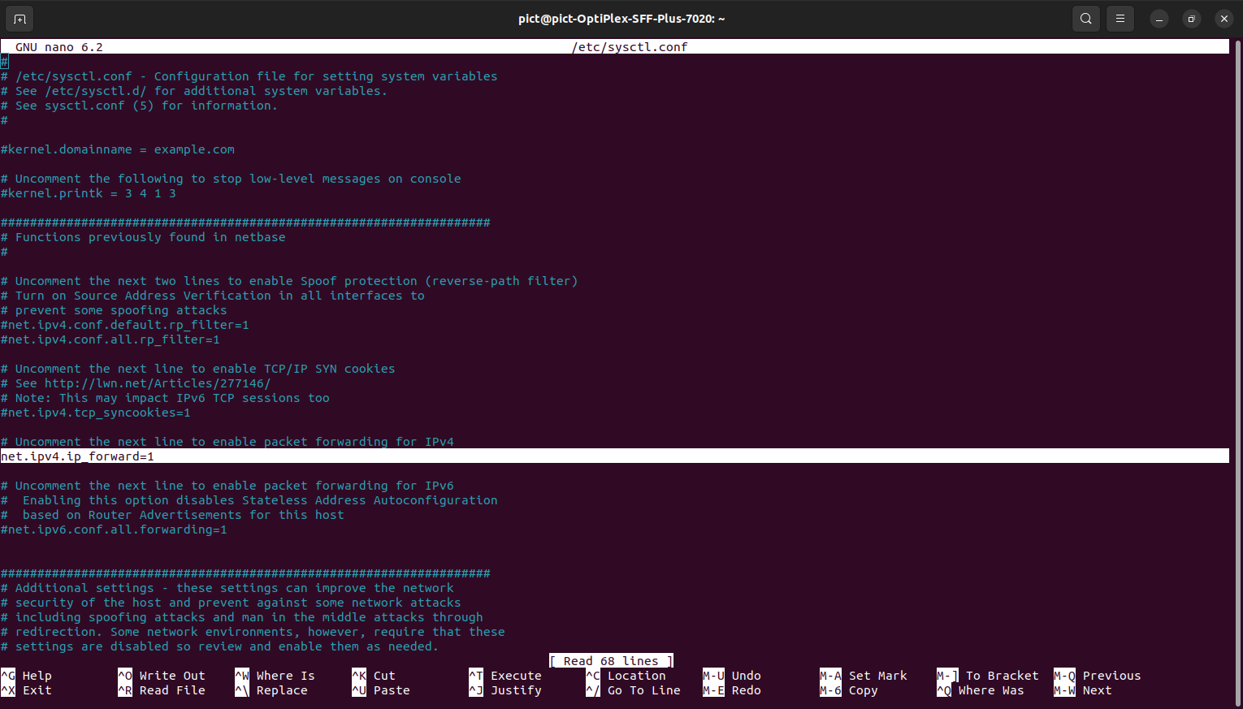
- Install: sudo apt install libosinfo-bin
Check supported OS: osinfo-query os
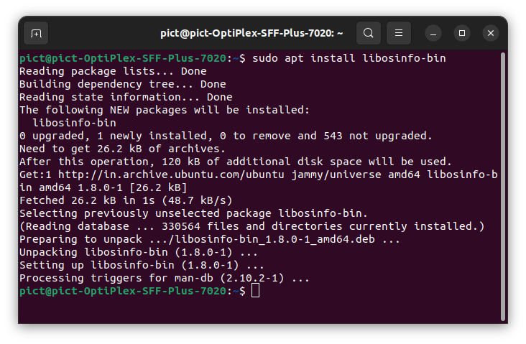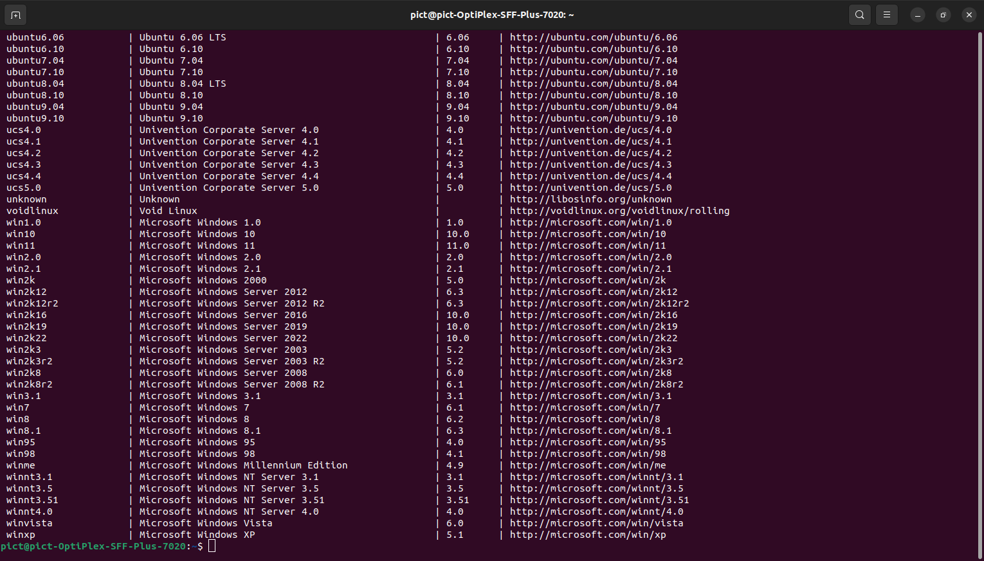

Run Alpine OS on VM

- Install Alpine OS
sudo wget -P /var/lib/libvirt/images/ https://dl-cdn.alpinelinux.org/alpine/v3.19/releases/x86_64/alpine-virt-3.19.1-x86_64.iso

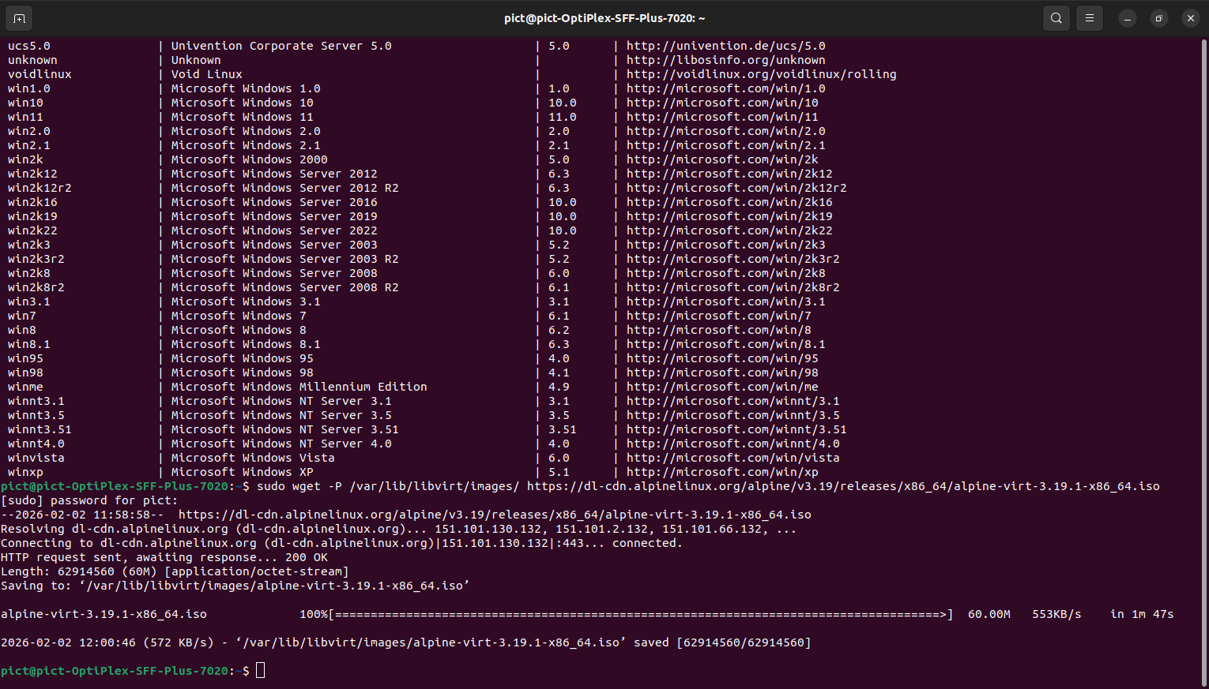

- Open Virtual Machine Manager from applications or use command sudo virt-manager
Right click on QEMU/KVM and select new
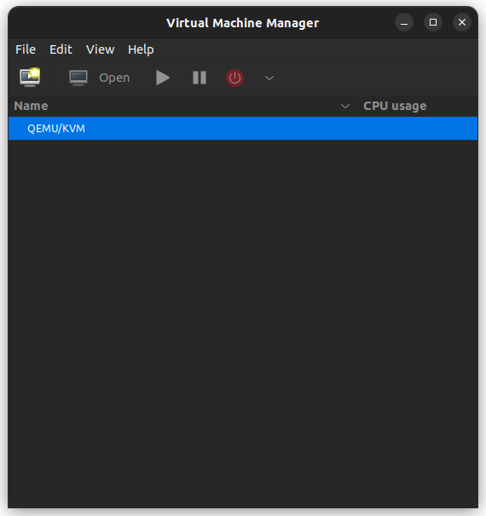

- Forward
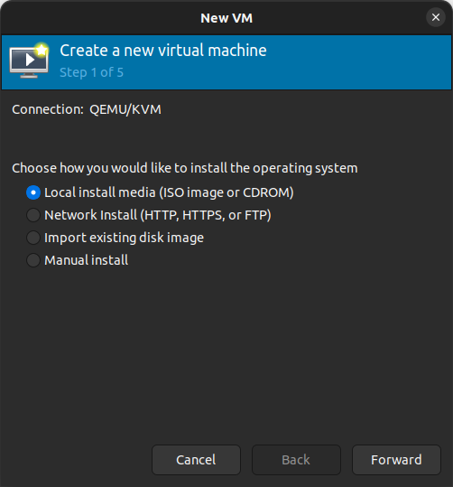

- Click on Browse and select Alpine OS -> click choose volume -> click Forward
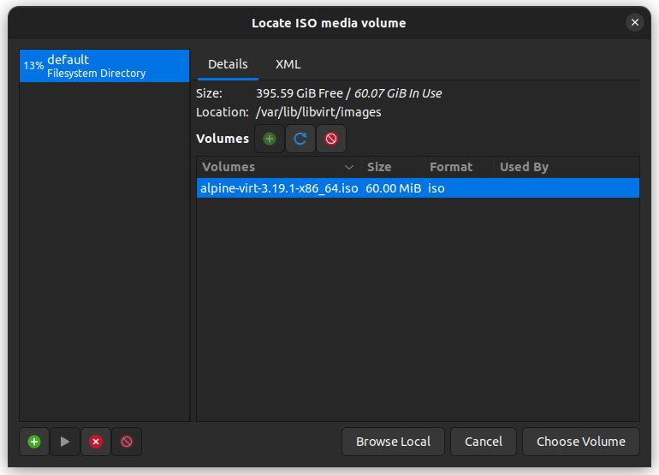
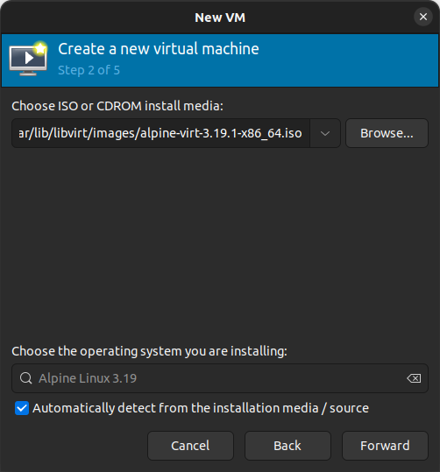

- Select 256 MB RAM & 1 CPU and Forward
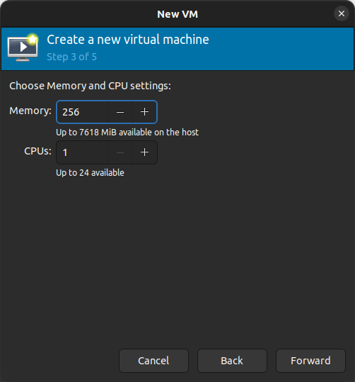

- Select 2GB of disk image and Forward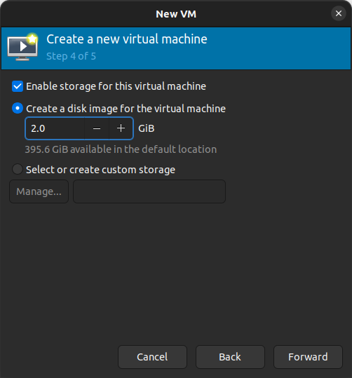

- Click Finish
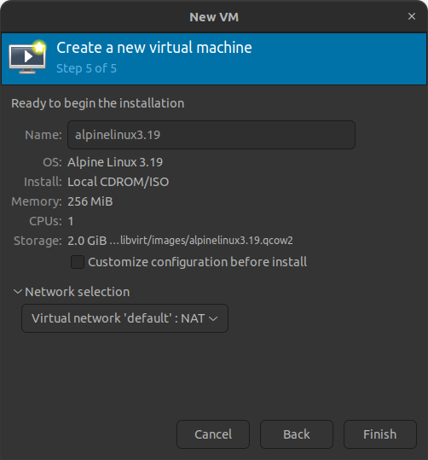

- Setup the OS according to your preference
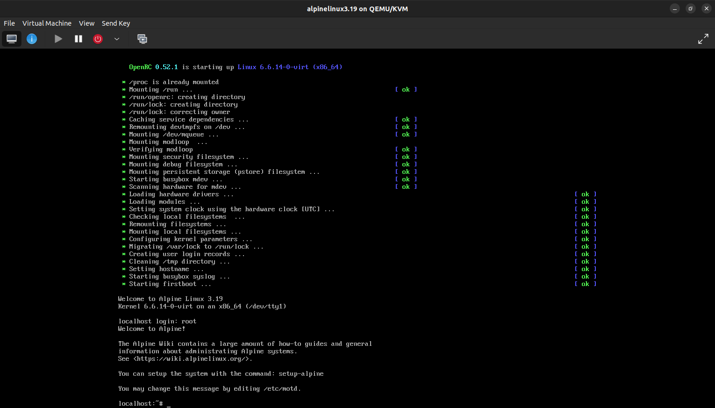

- After setup power off the VM (red button on top-left)
- Restart the virtual machine manager

- Run the Alpine OS whenever required
